OBJECTIVE: To calculate end to end communication time between Local Server and Central Server.

SET UP: To accomplish this task, a timer is started in the Local Server before establishing connection with the Central Server. The timer is stopped in the Local Server, after receiving the acknowledgement packet from the Central Server. The difference between the stop time and start time, fetches the delay.

OBSERVATIONS: The following data is obtained based on the observations:

Minimum Delay: 0.1774 s
Maximum Delay: 97.4576 s
Average Mean: 0.6616 s

DELAY HISTOGRAM:

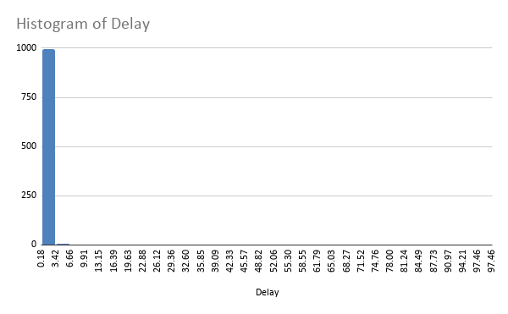

LINE CHART:

- Delay ranges from 0-100s
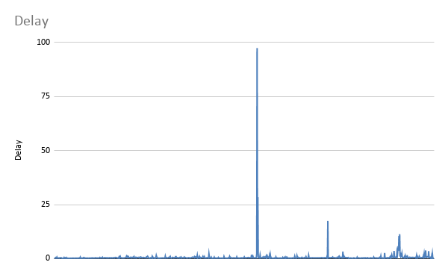
- Delay ranges from 0-25s
